

**CS423 DEVOPS**

**Assignment 2**

**Team:**

**Mahnoor Maleeka**

**2020217**

**Saad Khan**

**2020414**

**Github Link:**

<https://github.com/Mahnoor-Maleeka/devops_assignment2>

and

<https://github.com/theuppercaseguy/dev_assign_3>

Testing Environment Instance Ip:

18.234.116.171

Staging Environment Instance Ip:

52.87.188.51

Assignment 3 instance Ip:

3.84.5.63

**Task workflow pictures**

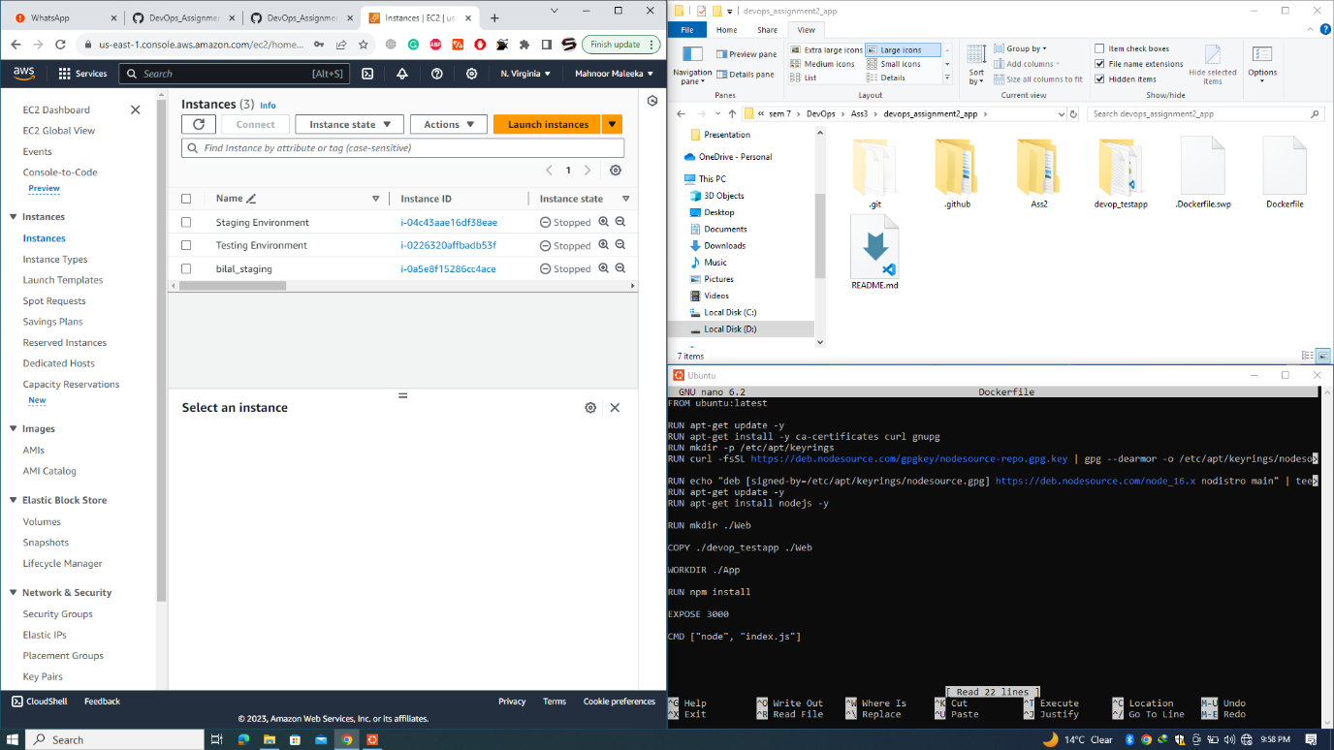

Containerized the previous web application

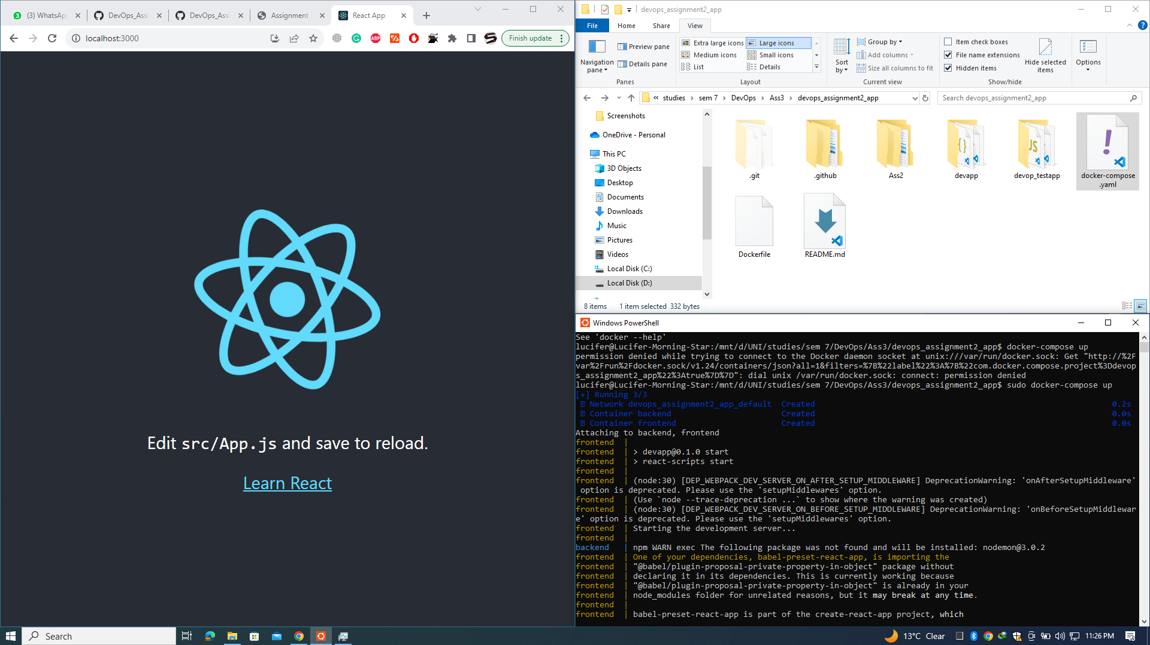

Running successfully on local machine

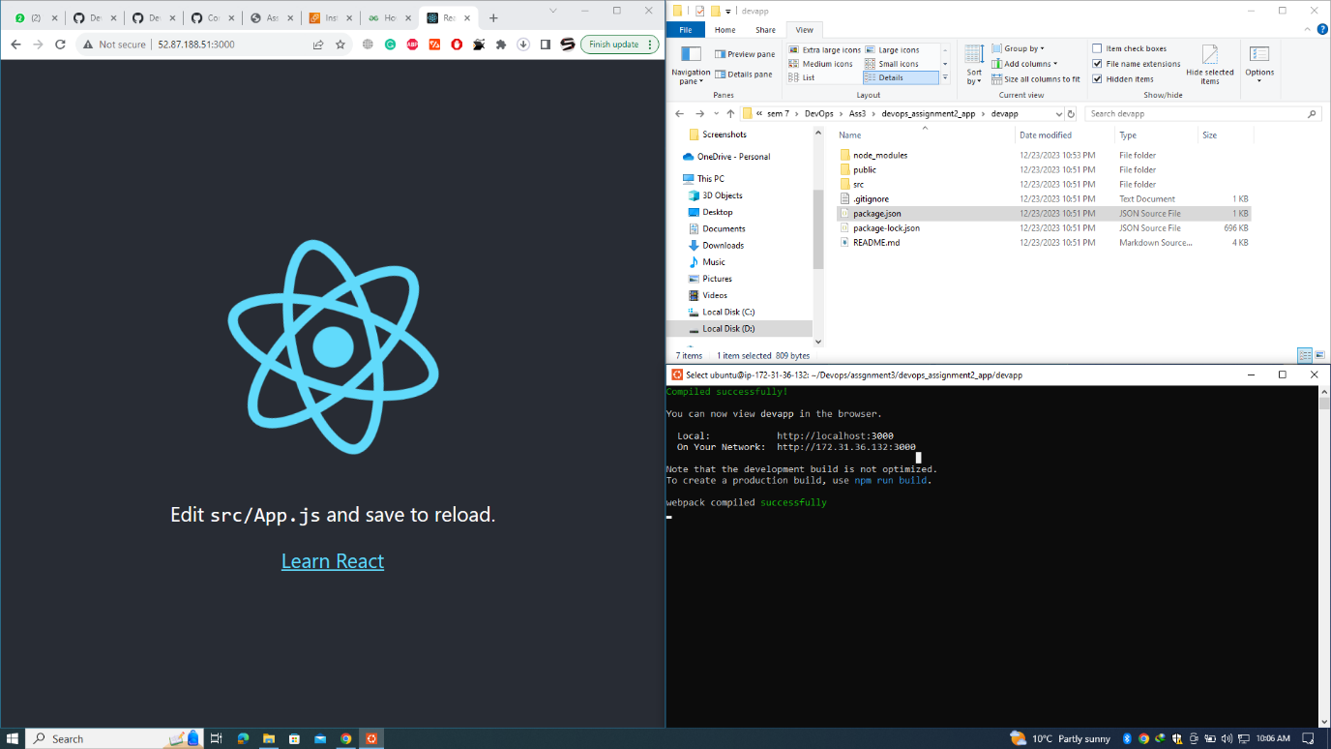

Uploading to the features branch

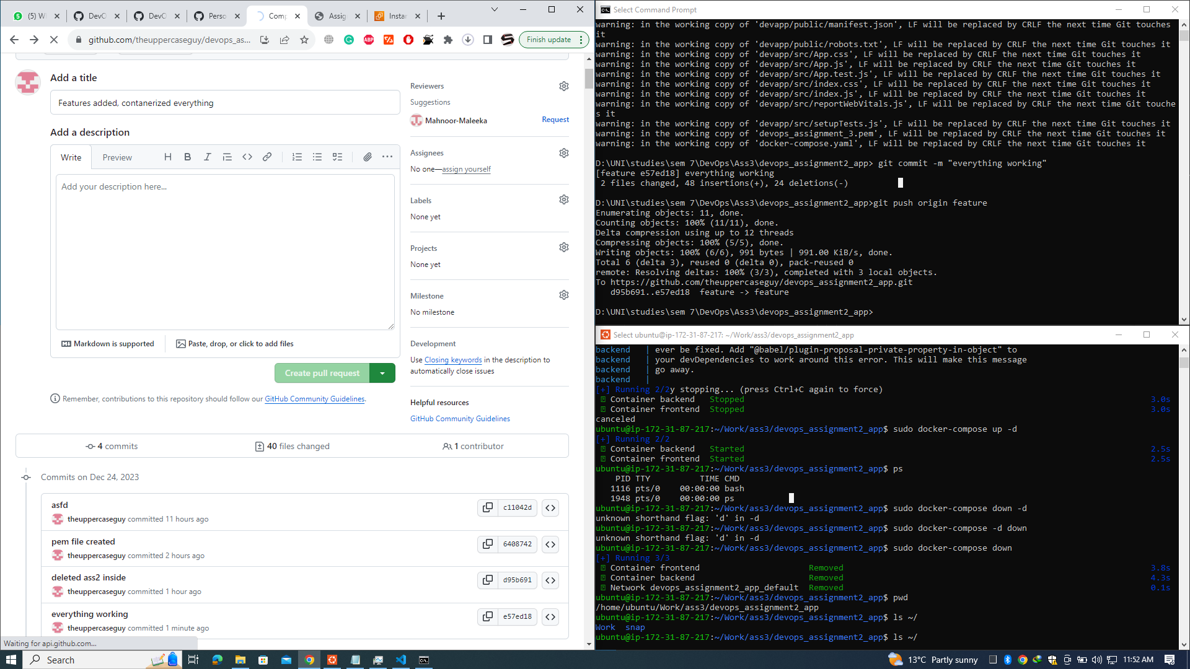Generating a pull request

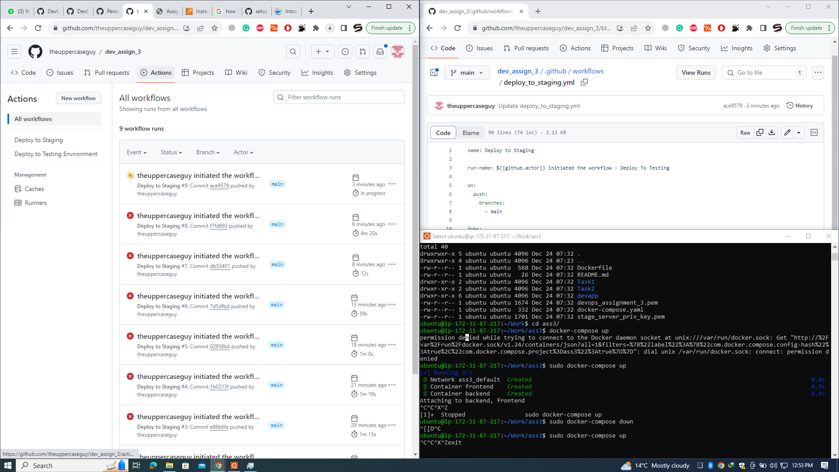

Workflow execution

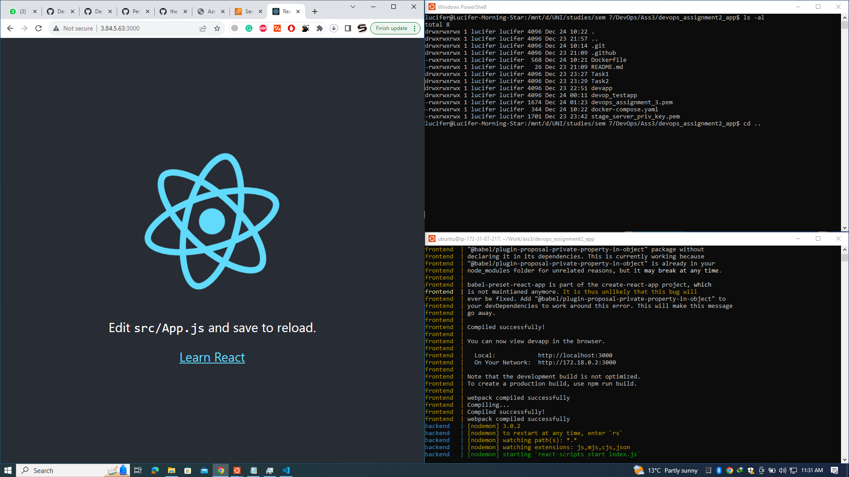

Successfully deployed